FOOD DETECTOR USING ARDUINO UNO

**A MINIPROJECT REPORT**

**Submitted in partial fulfilment of requirements for the award of the degree**

## BACHELOR OF TECHNOLOGY IN

**ELECTRONICS AND COMMUNICATION ENGINEERING**

By

|  |  |
| --- | --- |
| **Mr. PERIGISETTY SURESH** | **(18471A04K2)** |
| **Mr. RAJANALA KARTHIKEYA** | **(18471A04K6)** |
| **Mr. CHINTHAKUNTA SAI TEJA** | **(18471A04I4)** |
| **Mr. ANNALADASU PRASAD RAO** | **(18471A04I1)** |
| **Mr. ARIKATLA VENU GOPALA REDDY** | **(19475A0416)** |

### Under the guidance of Mr. G. SRINIVAS RAO

**Associate Professor**



**DEPARTMENT OF ELECTRONICS AND COMMUNICATION ENGINEERING**

### NARASARAOPETA ENGINEERING COLLEGE

**(Autonomous)**

**(Approved by AICTE, New Delhi, accredited thrice by NBA, accredited by NAAC with ‘A’ Grade, Affiliated to J.N.T.U.K, Kakinada and ISO 9001:2008 Certified Institution)**

**Kotappakonda Road, Yallamanda, Narasaraopet - 522601, Guntur (Dist.), Andhra Pradesh. February, 2021**

## NARASARAOPETA ENGINEERING COLLEGE

### (Autonomous)

**(Approved by AICTE, New Delhi, accredited thrice by NBA, Accredited by NAAC with ‘A’ Grade,Affiliated to J.N.T.U.K, Kakinada and ISO 9001:2008 Certified Institution)**

### Kotappakonda Road, Yallamanda, Narasaraopet - 522601, Guntur (Dist.), Andhra Pradesh.

**DEPARTMENT OF ELECTRONICS AND COMMUNICATION ENGINEERING**

**CERTIFICATE**



This is to certify that the mini project entitled **“FOOD DETECTION USING AURDUINO”** is the bonafied work carried out by **Mr. P. SURESH (18471A04K2), Mr. R. KARTHIKEYA (18471A04K6), Mr. CH. SAI TEJA (18471A04I4), Mr. A. PRASAD RAO**

**(18741A04I1), Mr. A. VENU GOPAL (19475A0416)** in partial fulfilment of the requirements for the award of the degree Bachelor of Technology in Electronics and Communication Engineering from Jawaharlal Nehru Technological University Kakinada, Kakinada during the year 2019- 2020 under my supervision and guidance.

### Project Guide Head of Department

**(Mr. G. SRINIVAS RAO) (Dr. V. VENKATA RAO)**

**External Examiner**

## ACKNOWLEDGEMENT

It is our pleasure to express our deep and sincere gratitude to our mini project guide **Mr.**

**G. Srinivas Rao**, Associate Professor, for extending his sincere and heartfelt guidance throughout this project work.

It is our desire to express sincere thanks to our mini project coordinator **Dr. B. Raghavaiah and Dr. Sreenivasa Ravi** Professors, for extending his cooperation and guidance throughout this project work.

We greatly indebted to **Dr.V.Venkata Rao**, Professor & Head of the Department, for providing motivation and valuable suggestions at every stage of our course of study.

We are thankful to our principal **Dr. M. Srinivasa Kumar** for providing us sparkling environment during our course of study.

We also express sincere thanks to **Sri M.V. KoteswaraRao**, Chairman of Narasaraopeta Engineering College, Narasaraopet for providing excellent infrastructural facilities to complete our course.

We extend our sincere thanks to all other Teaching and Non-Teaching Faculty members of the department for their cooperation and encouragement throughout our course of study.

We affectionately acknowledge our friends for their motivation and suggestions, which helps us in successfully completing our course.

We have no words to acknowledge the warm affection, constant inspiration and encouragement that we received from our Parents and Family Members.

### Project Associates

**Mr. Perigisetty Suresh 18471A04K2**

### Mr. Rajanala Karthikeya 18471A04K6

**Mr. Chinthakunta Sai teja 18471A04I4**

### Mr. Annaladasu Prasad Rao 18471A04I1

**Mr. Arikatla Venu Gopala Reddy 19475A0416**

|  |  |  |
| --- | --- | --- |
| **CONTENTS** | **INDEX** | **PAGE NO** |
| **LIST OF FIGURES** |  | **I** |
| **LIST OF TABLES** |  | **II** |
| **LIST OF ABBREVATIONS** |  | **III** |
| **ABSTRACT** |  | **IV** |

### CHAPTER 1: INTRODUCTION

* 1. Introduction 02
  2. Objectives of the project 03
  3. Outline of the project 03

CHAPTER 2: EXISTING METHODOLOGY

* 1. Literature review 05
  2. Existing method 06

CHAPTER 3: PROPOSED METHOD

* 1. Proposed method 08
  2. Block diagram 09
  3. Circuit diagram 10
  4. Working 11
  5. Principle 11
  6. Required modules

|  |  |  |
| --- | --- | --- |
| 3.6.1 | Arduino UNO | 11-14 |
| 3.6.2 | Atmega328P | 15 |
| 3.6.3 | LCD | 16-17 |
| 3.6.4 | Potentiometer | 17-18 |

* 1. Advantages | Disadvantages 18
  2. Applications 18

### CHAPTER 4: RESULT AND DISCUSSION

* 1. Result 20
  2. Discussion 21

### CHAPTER 5: CONCLUSION AND FUTURE SCOPE

|  |  |  |
| --- | --- | --- |
| 5.1 | Conclusion | 23 |
| 5.2 | Future scope | 23 |

**REFERENCE V**

**APPPENDIX:** Source code of project **VI**

## LIST OF FIGURES

## FIGURE.NO FIGURE NAME PAGE NO

3.1.1 Basic overview of the food detector 08

3.2.1 Block diagram of Food Detection 09

3.3.1 Circuit diagram of Food Detection 10

3.6.1.1 Pin diagram of Arduino UNO 13

3.6.2.1 Pin diagram of ATmega328P 15

3.6.3.1 LCD 16

3.6.4.1 Potentiometer 17

* + 1. Prototype circuit for food detector 20
    2. output of Food detector using Arduino 20

**I**

|  |  |  |
| --- | --- | --- |
| **TABLE.NO** | **LIST OF TABLES**  **TABLENAME** | **PAGE NO** |
| Table 3.6.1.2 | Pin description of Arduino UNO | 14 |
| Table 3.6.3.2 | Pin description of LCD | 16-17 |

## LIST OF ABBREVATIONS

LCD : Liquid Crystal Display

USB : Universal Serial Bus

IDE : Integrated Development Environment CLK : Clock Pulse

GND : Ground Terminal

PWM : Pulse Width Modulation ARFE : Analog Reference

SPI : Serial Peripheral Interface

LED : Light Emitting Diode

TTL : Transistor-Transistor Logic

AC : Alternating Currents

DC : Direct Currents

ICSP : In Circuit System Programming

FTDI : Future Technology Device International Limited SRAM : Static Random Access Memory

EEPROM : Electrically Erasable Programmable Read Only Memory SDA : Serial Data Line

# ABSTRACT

When we are at restaurant, we used to order our food. However, sometimes the chef would ask us to taste a new kind of dish, which is available only at his restaurant. Therefore, when we go through the dish, and we are unable to find out the ingredients that are present in the dish and we fell embarrassed to ask the chef about the ingredients that are added in the dish. To get rid this problem here we are with a solution called Food Detector using Arduino.

For every kind of fruit and vegetable, there are different resistance values. By taking this as the main point of our project. It also helps blind person to know about what they are eating.

# CHAPTER 1 INTRODUCTION

## Introduction to project :

Need of Food detector is just for the curiosity to know different types of food items like Vegetables, Fruits by taking their internal resistance as the reference. Using this food detector, we can also find out the nutritional values of the food through this device as the decrease in the resistance values indicates the loss of the nutrients in the food.

Taking an unhealthy food will lead to different kinds of disease. Food security exists when all people at all times have physical, social and economic access to sufficient, safe and nutrition food, which meets dietary, needs for an active and healthy life.

Food material with high quality, edible or nontoxic substances is called food quality. The substance, which degrades the quality of food material, may spoil many lives. Low quality food makes the customer unsafe in our daily life and unhygienic for use. In the past few decades, expiration of food and low quality food has become one of the serious problems. Consumption of expired food causes serious diseases like cancer, ulcers, asthma etc., the assurance and protection of food quality has always been important to man. The importance of certifying the quality of food and food products from the food industry will avoid health issues. In our daily life there are so many unhygienic and contaminated things are there. The term quality covers something different for people involved in the production and distribution of foods for consumers. The quality attribute of a particular product is based on the consumption of the product, packaging used etc., Food quality primarily involves safety, nutritive value and acceptance. Simply it is defined as fitness for purpose.

## Objectives of the project :

* + - To construct a simple Food detector using Arduino Uno.
    - A food detector is a device that detects the food item and nutritional quality checking by taking internal resistance of the food as a reference.
  1. **Outline of the project :**

The outline of the project is discussed below. They are

**CHAPTER 1:** Deals with the introduction, objectives of the project and the outline of the project.

**CHAPTER 2:** It consists of literature review.

**CHAPTER 3:** This chapter presents the methodology, which consists of various methods like existing and proposed methods, also gives the detailed idea of Food detector using Arduino Uno.

**CHAPTER 4:** It consists of result and discussion.

**CHAPTER 5:** Here we have conclusion and future scope of our project.

# CHAPTER 2 EXISTING METHODOLOGY

### LITERATURE REVIEW:

Food safety and hygiene is a major concern in order to prevent the food wastage. The nutritional quantity of the food needs to be monitored and it must be prevented from rotting and decaying by the atmospheric factors like temperature, humidity and dark. Therefore, it is useful to deploy nutrition quantity monitoring device at food stores.

These nutrition quantity-monitoring devices keep a watch on the environmental factor that cause or pace up decay of the food. Later the environmental factors can be controlled like by refrigerators, vacuum storage etc. In this paper, a similar food nutritional quantity and type of food detection device will be designed that will keep watch of environmental factors like temperature, humidity, alcohol content and explore to light. The device is built on Arduino UNO, which is a popular prototyping board. The Arduino board is interfaced with a LCD that displays the nutritional values of the food item, which we are ready to find out. It is also connected at their respective ports to introduce the polarities in to the food that we want to detect. The nutritional values. A potentiometer meter is also connected for the variable resistance purpose to increase and decrease the intensity of light on the LCD. Based on the resistance of the food, the item will be displayed on the LCD for the user.

## EXISTING METHOD:

Food detector and nutrients quantity is described to combat corruption in public distribution system (PDS). The system administrator can have a check on the availability of ratio to beneficiary on one side and the other side the customer can find out the nutrients quantity that are given by the government in Public Distribution Shops (PDS).

In the existing methodology, the texture analysis gives weather the given food is in good quality or not. Some health issues will occur due to the low nutritional food. The shopkeeper does not cheat customers by selling low quality or decayed food items. Customer monitor the product at the time of purchase. In

this existing method, only the texture and PDS transparency and the achiever reliable accountability in the transaction of goods alone done. This work will detect the food nonrationality.

# CHAPTER 3 PROPOSED METHODOLOGY

## Proposed method:

Food safety is an important public health problem that relates to human health and economic development. Contaminated food material brings a lot of easy money to the traders, but it may spoil many lives. Low nutritional food can lead to slow poisoning and various kinds of diseases, which can even result in death. To overcome these types of drawbacks we have designed this proposed system for checking type of food nutritional quantity. In our method, the main module is resistance of the food item to detect and to display the nutritional values. The output of the Arduino UNO is through the LCD screen, which displays the type of food detected and the nutritional values of the food.

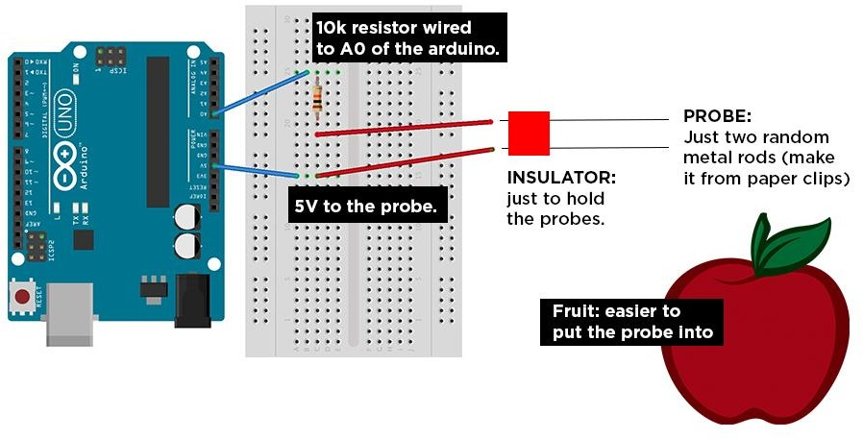

### Fig. 3.1.1 Basic overview of the Food detector.

As shown in the above fig. 3.0, this is the basic methodology and over view of the food detector.

## Block Diagram:

FOOD

INPUT

ARDUINO

UNO

LED

DISPLAY

POWER

SUPPLY

**Fig 3.2.1: - Block diagram of food detection**

The figure shows the block diagram of Food detector and nutritional quantity. The polarities are immersed in to the type of food that, we want to detect. Power supply of 9V, given to the Arduino UNO. An LCD is connected to the Arduino to display the type of food and nutritional values.

## Circuit Diagram:

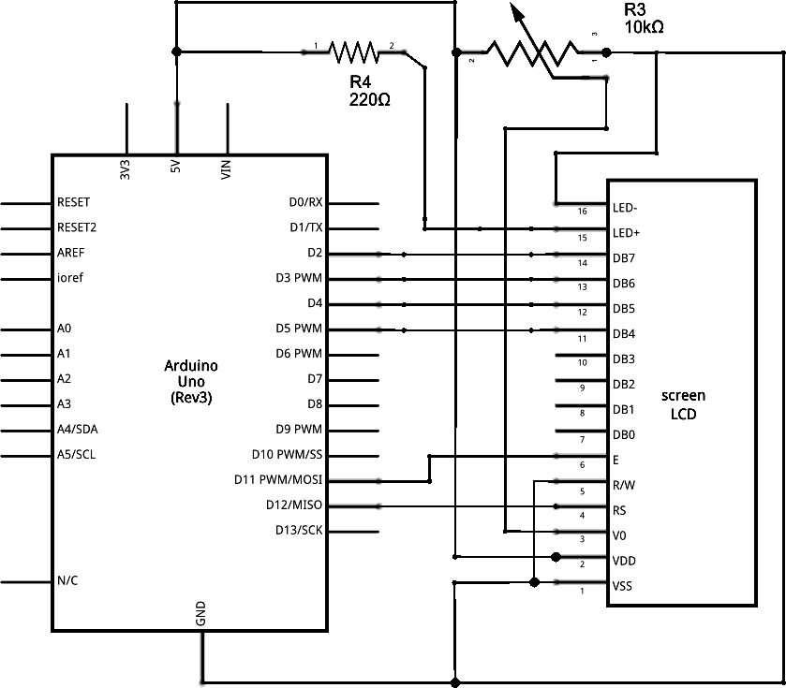

### Fig 3.3.1: Circuit diagram of Food Detector.

The above diagram shows the circuit diagram for the food detector using Arduino. It consists of an Arduino board, LCD, Potentiometer and 10k ohm resistor. Connect the A0 of Arduino UNO R3 and a resistor with a wire.

Connect the probe (metal rod) to another leg of the resistor. Connect the +5V and probe.

## Working:

A simple cheap and effective food detector and nutritional quantity retrieving has been developed in this project.

Different foods have different resistances, you can use food detector to detect your unknown food and unknown nutritional values by just putting it into IF and ELSE loop

The circuit is based on detecting internal resistance of the given fruit or vegetables, we initially check the resistance of the different kinds of food item and code it in to the Arduino. When the probes are connected to the fruit or vegetable, it take the internal resistance of that fruit or vegetable and finally executes in the loop. So, if the gathered resistance is equal to the internal resistance then the particular fruit or vegetable with nutritional quantity, will be displayed on the LCD screen.

## Principle:

The project works on the principle of internal resistance of the food item. If the internal resistance of the food item is equal to the given resistance range in the IF and ELSE loop then the particular food will be display on the LCD screen.

## Required modules:

* + - Arduino Uno
    - LCD
    - Potentiometer
    - Resistors
    - Jumper wires

## Arduino UNO:

Arduino is an open source computer hardware and software company, project, and user community that designs and manufactures [single-board microcontrollers](https://en.wikipedia.org/wiki/Single-board_microcontroller) and [microcontroller](https://en.wikipedia.org/wiki/Microcontroller) kits for building digital devices and interactive objects that can sense and control objects in the physical world.

Arduino board designs use a variety of microprocessors and controllers. The boards are equipped with sets of digital and analog [input/output](https://en.wikipedia.org/wiki/Input/output) (I/O) pins that may be interfaced to

various expansion boards (shields) and other circuits. The boards feature serial communications interfaces, including [Universal Serial Bus](https://en.wikipedia.org/wiki/Universal_Serial_Bus) (USB) on some models, which are also used for loading programs from personal computers. The microcontrollers are typically programmed using a dialect of features from the programming languages [C](https://en.wikipedia.org/wiki/C_%28programming_language%29) and [C++](https://en.wikipedia.org/wiki/C%2B%2B). In addition to using traditional compiler tool chains, the Arduino project provides an [integrated](https://en.wikipedia.org/wiki/Integrated_development_environment) [development environment](https://en.wikipedia.org/wiki/Integrated_development_environment) (IDE) based on the [Processing](https://en.wikipedia.org/wiki/Processing_%28programming_language%29) language project.

## Features of Arduino Uno

The features of Arduino Uno ATmega328 include the following.

* + - * The operating voltage is 5V
      * The recommended input voltage will range from 7v to 12V
      * The input voltage ranges from 6v to 20V
      * Digital input/output pins are 14
      * Analog input pins are 6
      * DC Current for each input/output pin is 40 mA
      * DC Current for 3.3V Pin is 50 mA
      * Flash Memory is 32 KB
      * SRAM is 2 KB
      * EEPROM is 1 KB
      * CLK Speed is 16 MHz

## Technical specifications:

* + - * Micro controller - AT mega 328P
      * Operating voltage - 5V
      * Recommended voltage - 7-12V
      * Input voltage limits - 6-20V
      * Analog input pins - 6(A0-A5)

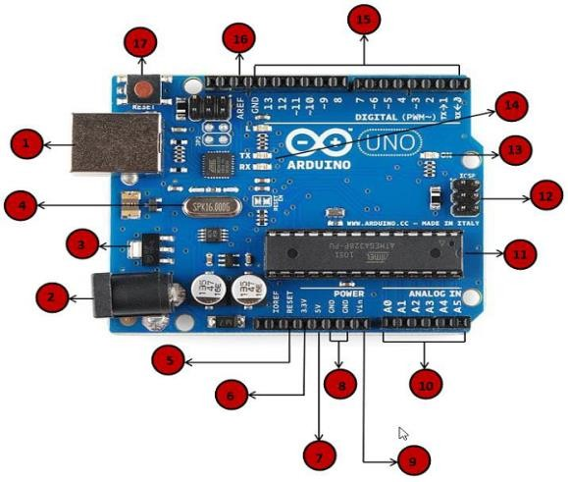

### Fig:-3.6.1.1: Arduino Uno

. The above figure shows the pin diagram of Arduino UNO which consists of 20 pins. It has six analog pins (A0, A1, A2, A3, A4, and A5) and a ground pin, reset pin, 3.3V pins, 5V pin. It has 14 digital pins (0 to 13). ATmega328 microcontroller is present on the board. A serial pin (transmitter) and a serial out (receiver) is used.

## Pin description:

|  |  |  |
| --- | --- | --- |
| **Pin Category** | **Pin Name** | **Details** |
| Power | Vin, 3.3V, 5V, GND | Vin: Input voltage to Arduino when using an external power source.  5V: Regulated power supply used to power microcontroller and other components on the board.  3.3V: 3.3V supply generated by on-board voltage regulator. Maximum current draw is 50mA.  GND: ground pins. |
| Reset | Reset | Resets the microcontroller. |
| Analog Pins | A0 – A5 | Used to provide analog input in the range of 0-5V |
| Input/Output Pins | Digital Pins 0 - 13 | Can be used as input or output pins. |
| Serial | 0(Rx), 1(Tx) | Used to receive and transmit TTL serial data. |
| External Interrupts | 2, 3 | To trigger an interrupt. |
| PWM | 3, 5, 6, 9, 11 | Provides 8-bit PWM output. |
| SPI | 10 (SS), 11 (MOSI), 12 (MISO) and 13 (SCK) | Used for SPI communication. |
| Inbuilt LED | 13 | To turn on the inbuilt LED. |
| TWI | A4 (SDA), A5 (SCA) | Used for TWI communication. |
| AREF | AREF | To provide reference voltage for input voltage. |

**Table: 3.6.1.2: Pin description of Arduino UNO**

## Pin diagram of Atmega328P:

Arduino is an open source computer hardware and software company, project, and user community that designs and manufactures [single-board microcontrollers](https://en.wikipedia.org/wiki/Single-board_microcontroller) and [microcontroller](https://en.wikipedia.org/wiki/Microcontroller) kits.

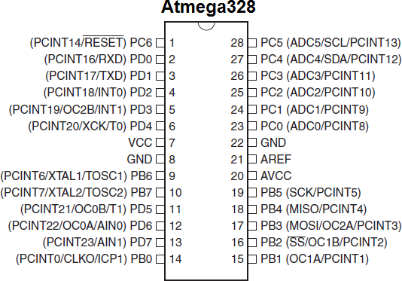

## LCD:

### Fig 3.6.2.1: Pin Diagram

An LCD (Liquid Crystal Display) screen is an electronic display module and has a wide range of applications. A 16x2 LCD display is very basic module and is very commonly used in various devices and circuits. A 16x2 LCD means it can display 16 characters per line and there are two such lines. In this LCD, each character is displayed in 5x7-pixel matrix. The 16 x 2 intelligent alphanumeric dot matrix display is capable of displaying 224 different characters and symbols. This LCD has two registers, namely, Command and Data.

Command register stores various commands given to the display. Data register stores data to be displayed. The process of controlling the display involves putting the data that form the

image of what you want to display into the data registers, then putting instructions in the instruction register. In your Arduino project, Liquid Crystal Library simplifies this for you so you do not need to know the low-level instructions. Contrast of the display can be adjusted by adjusting the potentiometer to be connected across VEE pin.

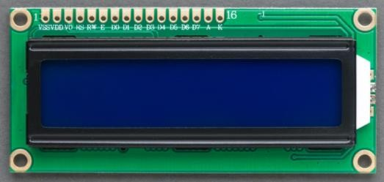

## Pin Configuration:

### Fig-3.6.3.1: Liquid Crystal Display

|  |  |  |  |  |
| --- | --- | --- | --- | --- |
| **Sr. No** | **Pin No.** | **Pin Name** | **Pin Type** | **Pin Description** |
| 1 | Pin 1 | Ground | Source Pin | This is a ground pin of LCD |
| 2 | Pin 2 | VCC | Source Pin | This is the supply voltage pin of LCD |
| 3 | Pin 3 | V0/VEE | Control Pin | Adjusts the contrast of the LCD. |
| 4 | Pin 4 | Register Select | Control Pin | Toggles between Command/Data Register |
| 5 | Pin 5 | Read/Write | Control Pin | Toggles the LCD between Read/Write Operation |
| 6 | Pin 6 | Enable | Control Pin | Must be held high to perform Read/Write Operation |

|  |  |  |  |  |
| --- | --- | --- | --- | --- |
| 7 | Pin 7-14 | Data Bits (0-7) | Data/Command Pin | Pins used to send Command or data to the LCD. |
| 8 | Pin 15 | LED  Positive | LED Pin | Normal LED like operation to illuminate the LCD |
| 9 | Pin 16 | LED  Negative | LED Pin | Normal LED like operation to illuminate the LCD connected with GND. |

**Table 3.6.3.2: Pin Configuration of LCD**

## POTENTIOMETER:

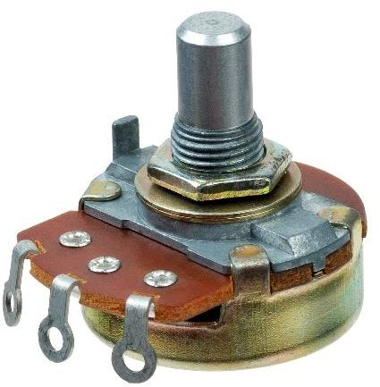

### Fig 3.6.4.1:-Potentiometer

A **potentiometer** is a three-terminal resistor with a sliding or rotating contact that forms an adjustable voltage divider. If only two terminals are used, one end and the wiper, it acts as a **variable resistor** or **rheostat**.

The measuring instrument called a potentiometer is essentially a voltage divider used for measuring electric potential (voltage); the component is an implementation of the same principle, hence its name.

Potentiometers are commonly used to control electrical devices such as volume controls on audio equipment. Potentiometers operated by a mechanism can be used as

position transducers, for example, in a joystick. Potentiometers are rarely used to directly control significant power (more than a watt), since the power dissipated in the potentiometer would be comparable to the power in the controlled load.

## Advantages | Disadvantages:

* + - This helps in identifying the various types food that we tend to eat.
    - It can be used as a futuristic learning process of the different types of eatables.
    - Complexity in designing this is very low.

### Disadvantages:

* System not able to read exact value of resistance using jumper wires.
* Resistance values of some fruits/vegetables keeps changing in accordance to their usage in different food items.

## Applications:

* + - Restaurants
    - Home
    - Hotels

# CHAPTER 4 RESULT AND DISCUSSION

## Result:

**Prototype circuit:**

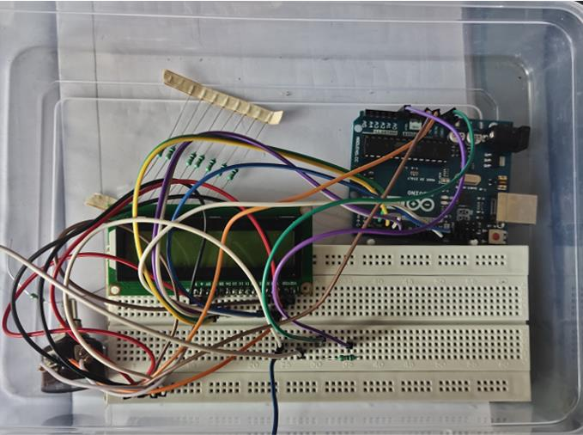

## Fig 4.1.1: Prototype circuit for food detector using Arduino.

**Output:**

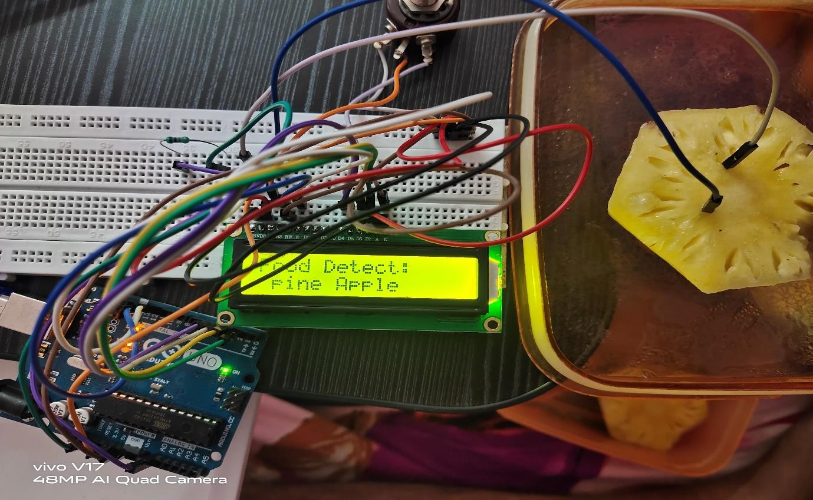

## Fig 4.1.2 Output of food detector using Arduino.

* 1. **Discussion:**

In our project, internal resistance is the core of the food detection and nutritional quantity detection.

Different foods have different resistances, you can use food detector to detect your unknown food and unknown nutritional values by just putting it into IF and ELSE loop

The circuit is based on detecting internal resistance of the given fruit or vegetables, we initially check the resistance of the different kinds of food item and code it in to the Arduino. When the probes are connected to the fruit or vegetable, it take the internal resistance of that fruit or vegetable and finally executes in the loop. So, if the gathered resistance is equal to the internal resistance then the particular fruit or vegetable with nutritional quantity, will be displayed on the LCD screen.

# CHAPTER-5 CONCLUSION AND FUTURE SCOPE

## CONCLUSION:

The paper has introduced the idea of automated homes and proposed a method which saves power consumption by system. This Automated Gadget Control System having the interconnections between the home appliances and sensors for controlling and monitoring the device. Automated home is a vast system that having multiple technologies and its applications that can be used to provide control and security of the homes easily.

The hardware implemented using Arduino Uno; hence, the system is small also comfortable to carry along.

## FUTURE SCOPE:

* + - This application can used by consumers to detect how much time their food stays fresh.
    - With the use of this application, users can also determine the taste of food.
    - User can also get output in the form of voice by attaching speaker with circuit.
    - User can also detect inhabitant food.

It can further be developed to determine the nutritional values of the food.

# REFERENCES

## Web sites: -

* [www.arduino.cc](http://www.arduino.cc/)
* [www.wikipedia.org](http://www.wikipedia.org/)
* [www.huckster.io](http://www.huckster.io/)
* [www.engineeringfun.org](http://www.engineeringfun.org/)
* [www.miniprojects.org](http://www.miniprojects.org/)

## Books:-

* Beginning Arduino by Michel McRoberts.
* Getting Started with Arduino by Massimo Banzi.

ELECTRONICS AND COMMUNICATION ENGINEERING V

# APPENDIX

## CODE:

const int frootSense = 0;

int frootResistance, high = 0, low = 1023; int frootDetect;

#include <LiquidCrystal.h> //remove this if u don't have LCD, anyways it wont affect. LiquidCrystal lcd(12,11,5,4,3,2); //remove this if u don't have LCD, anyways it wont affect. void setup(){

Serial.begin(9600);

lcd.begin(16, 2); //remove this if u don't have LCD, anyways it wont affect. lcd.clear(); //remove this if u don't have LCD, anyways it wont affect.

}

void loop()

{

lcd.clear(); //remove this if u don't have LCD, anyways it wont affect. lcd.setCursor(0,0); //remove this if u don't have LCD, anyways it wont affect. lcd.print("Food Detect:"); //remove this if u don't have LCD, anyways it wont affect. lcd.setCursor(0,1); //remove this if u don't have LCD, anyways it wont affect. frootResistance = analogRead(frootSense);

Serial.print("Resistance:"); Serial.print(frootResistance); Serial.print("\n");

if (frootResistance>400 & frootResista nce<700){ Serial.print("Cucumber \n");

lcd.print("Cucumber"); //remove this if u don't have LCD, anyways it won’t affect.

}

else if(frootResistance>140 & frootResistance<300){

Serial.print("Apple");

lcd.print("Apple"); //remove this if u don't have LCD, anyways it wont affect.

}

else if(frootResistance>800 & frootResistance<1100){ Serial.print("Pine Apple");

lcd.print("Pine Apple"); //remove this if u don't have LCD, anyways it wont affect.

else {

Serial.print("No Food \n");

lcd.print("No Food"); //remove this if u do not have LCD, anyways it won’t affect.

}

delay(1000);

}